What will we be learning?  Unit FO97 – Supporting healthy nutrition and lifestyles | Why this? Why now?  This unit is completed in Year 13. It is an optional unit. It runs alongside F091 the examined unit and F094 coursework unit during Year 13. | Key Words/terms:  Macronutrients  Micronutrients  Energy balance  Food intolerance  Auto-immune  Gastro-intestine
What will we learn?
- TA1 – Dietary and activity needs of individuals
- TA2 – Factors that influence dietary choices and physical activity levels
- TA3 – Supporting individuals to plan meals and meet their needs

What opportunities are there for wider study?
Careers/degree courses
- Social care
- Childcare
- Health care

Further reading:
Describe different working relationships in care settings – DSDWEB: FREE STUDY GUIDES FOR CARE QUALIFICATIONS
Timeline of Baby P case - BBC News
Inquiry investigates deaths of 1,500 NHS mental health patients in Essex | Mental health | The Guardian
How will I be assessed?
- OCR set assignments on Teams.
AAQ – HEALTH & SOCIAL CARE
UNIT F097

TA1 – DIETARY AND ACTIVITY NEEDS OF INDIVIDUALS  - Dietary needs  - Physical activity guidelines and energy balance | 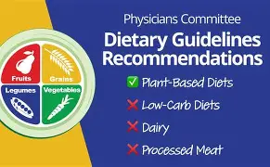
TA2 – FACTORS INFLUENCING DIETARY CHOICES & PHYSICAL ACTIVITY LEVELS  2.1 Factors that influence dietary choices  2.2 Digestive disorders  2.3 Factors that influence physical activity levels  2.4 Understanding factors relating to diet and physical activity levels | 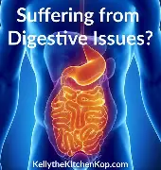
TA3 – SUPPORTING INDIVIDUALS TO PLAN MEALS THAT MEET THEIR NEEDS  - Meal planning  - Food labelling  - Supporting social interaction at mealtimes | 

